Fine Scale Measurement of Ballast-Tie Pressure Distribution
Mike McHenry¹, Jerry Rose², and Reginald Souleyrette²

¹ Transportation Technology Center, Inc. 55500 DOT Rd. Pueblo, CO
² Department of Civil Engineering, University of Kentucky, Lexington, KY

This investigation involves the measurement of fine-scale pressures at the ballast-tie interface of conventional ballasted track. To further understand the forces that act at this interface, the use of Matrix Based Tactile Surface Sensors (MBTSS) is employed to measure a more fine-scale pressure distribution at the ballast-tie interface, characterized by individual ballast particle contact points and non-uniform pressure distributions. In partnership with Transportation Technology Center, Inc. (TTCI), laboratory ballast box testing and in-track testing at the Facility for Accelerated Service Testing (FAST) were conducted. Results from laboratory ballast box testing show that conservative estimates of peak pressure under a typical wheel load on new ballast averaged 1450 psi and on fouled ballast averaged 681 psi. Contact areas varied across the range of ballast gradations and are shown to increase under increased applied load. Results from in-track testing performed at TTCI, including pressure distributions along the length of a test tie, is also presented. The pressure distribution at the ballast-tie interface of railroad track plays a key role in overall track support. Understanding the forces acting on the ballast and tie are required to design higher performance and longer lasting track.

Introduction
The ballast-tie interface is an important area of the conventional railroad track structure. Contributing to functions of the tie and ballast, the interface serves the purpose of initiating the pressure distribution through the ballast layer, allowing for adjustment of track geometry (tamping/surfacing) and providing vertical, lateral, and longitudinal track stability.
In North American practice, the ballast-tie contact surface is typically approximated as two-thirds the tie footprint (the outer third on each end of the tie) [1]. In reality, however, ballast-tie pressures vary continuously along the length of the tie; early research by Talbot supports this conclusion [2]. The variability of pressure along the length of the tie has a significant impact on the design tie strength that is required. Concrete tie center cracking is one possible failure when loading conditions exceed the tie’s design capacity. On a finer scale, the ballast-tie interface is characterized by high pressures caused by the individual angular ballast particles supporting the tie. Low contact area and the resulting high pressures on the ballast particles and tie may contribute to ballast particle breakage, tie surface degradation, ballast degradation, and track settlement.
The current study was undertaken to better quantify the fine-scale pressures acting at the ballast-tie interface and the pressure distribution along the length of the tie. Matrix Based Tactile Surface Sensors (MBTSS) were used in laboratory testing and in-track testing at TTCI to characterize this pressure distribution.

MBTSS System
The MBTSS system used for this research measures fine-scale pressure distributions between two surfaces in contact. The system is composed of a thin sensor (a), a data acquisition device (b), and a computer running the data acquisition/analysis software (c) as shown in Figure 1.
The sensors are made of two thin polyester sheets that have electrically conductive rows and columns printed on them. The conductive rows and columns, when overlapped, form a matrix grid of sensing elements, or “pressure pixels.” Pressure is measured at each sensing element. Because area of each sensing element is sufficiently small, the contact pressures due to individual ballast particles can be realized. The sensors are protecting with rubber sheets.
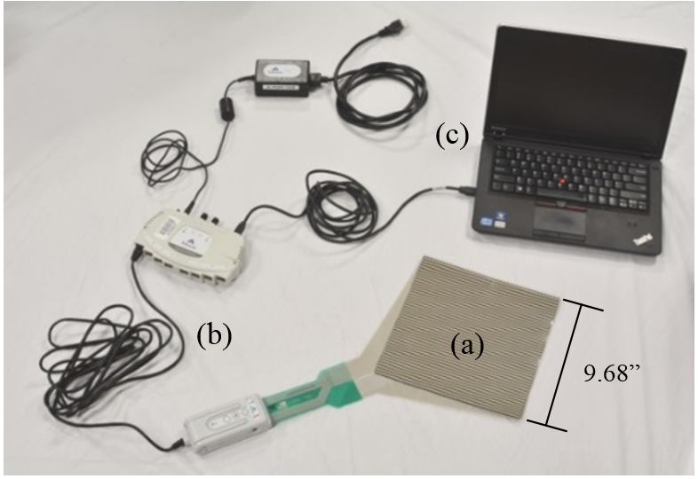
Figure 1. MBTSS system components

Test Setup
Laboratory testing took place at TTCI’s Component Test Laboratory (CTL). Ballast boxes were used to contain various ballast materials. Five gradations of dried granular material were used - new ballast, moderately degraded ballast, heavily degraded ballast, pea gravel, and sand – to represent various contact surface roughness.
The ballast boxes were filled with each of the five gradations and placed in the load frame. The ballast surfaces were loaded with a section of tie, placing the MBTSS between the tie and ballast surfaces. The tie section was loaded with cyclic loads ranging from 2 kips to 20 kips, a load approximating a typical wheel load in revenue service. Figure 2 show the configuration of the ballast box test and location of the pressure sensor.
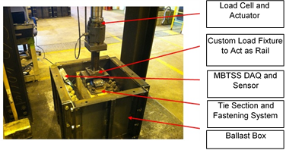
Figure 2. Laboratory ballast box test configuration
In-track testing was conducted at TTCI’s High Tonnage Loop (HTL) at FAST, in June 2013. Tangent track with conventional monoblock concrete ties (with a footprint 102 inches long by 10.5 inches wide) spaced at 24 inches on center was used for this testing. Five three-tie test zones were established (15 total test ties). To simulate the effect of various ballast gradations at the ballast-tie interface, different ballast materials were installed beneath each zone’s three ties. Similar to the laboratory ballasts, sand degraded ballast, pea gravel, heavily degraded ballast, moderately degraded ballast, and new ballast were used.
To install the MBTSS system, the crib ballast was excavated down to the bottom of the ties, the rail fasteners removed from adjacent ties, the test tie raised slightly. The pressure sensors and rubber protection sheets were then slid beneath the tie, as shown in Figure 3.
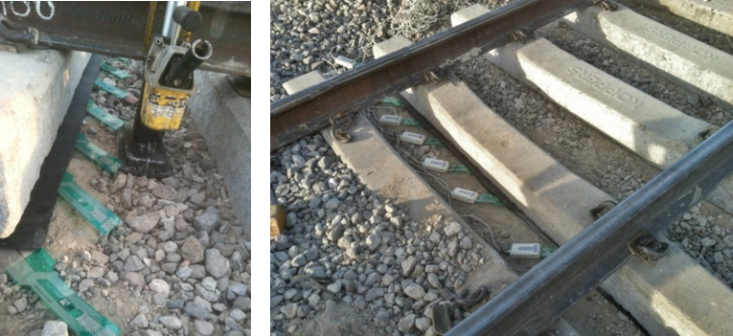
Figure 3. Installation and location of the sensors at the ballast-tie interface
A six-axle locomotive, empty car, and heavy car were used to apply loading to the test ties.

Results
The MBTSS system can distinguish variations in pressure distribution for the range of ballast gradations tested. Expectedly, new ballast exhibited sharp pressure peaks and lower relative contact areas. Degraded ballast distributions had higher contact areas and slightly “duller” pressure peaks. Sand distributions were relatively uniform and lacked any significant peaks of pressure. Figure 4 shows a typical pressure distribution for each of the five gradations.
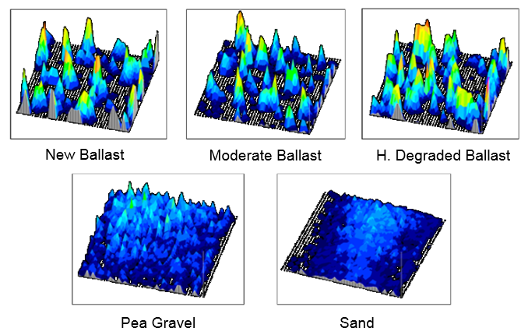
Figure 4. Qualitative pressure distributions for the five ballast surfaces tested in the laboratory ballast boxes
Figure 5 shows peak pressure versus applied load for the five ballast surfaces.
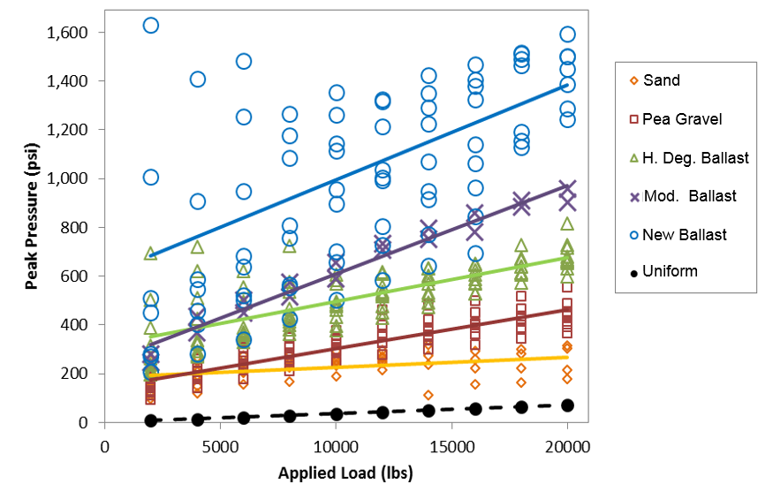
Figure 5. Peak pressure versus applied load for the five ballast surfaces tested in the laboratory
Figures 6 and 7 show the pressure distribution along two ties showing the range of variability observed for the test ties. Distributions for the empty car wheel loads, locomotive wheel loads, heavy car wheel loads, and the AREMA-recommended distribution for the heavy car wheel load is shown.
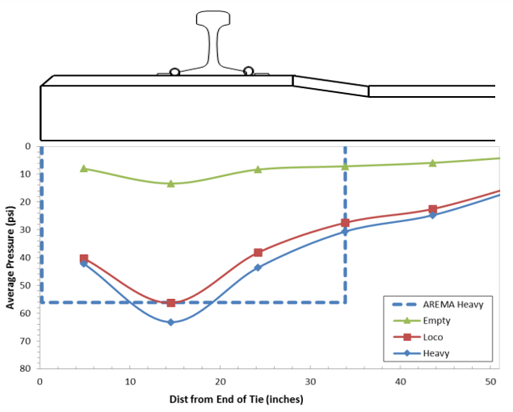
Figure 6. Pressure distribution measured along the length of Tie 3 (existing moderately degraded ballast)
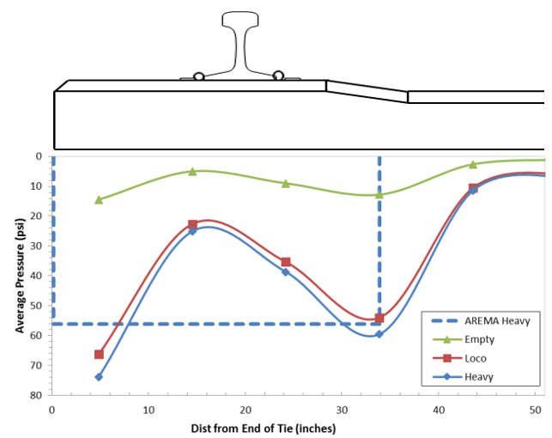

Figure 7. Pressure distribution measured along the length of Tie 39 (new ballast) showing load concentrations adjacent to the rail, not directly beneath it

Conclusion
Laboratory results showed that the contact area at the ballast-tie interface increases with increasing applied load (as additional ballast particles are engaged). However, results also indicate that only a few particles carry much higher peak pressures, upwards of 1400 psi for new ballast under a typical wheel load.
In-track testing, in general, confirmed the variability of support conditions (load distribution) in-track, even for adjacent ties. Six of ten ties showed pressure distributions with two higher load concentrations adjacent to the rail, and not directly beneath it, as is typically assumed. This represents an interesting finding and one that disagrees significantly with the average pressure distribution on the outer thirds of the tie recommended in the AREMA Manual for Railway Engineering. These local peaks of pressure appear to correspond with the area of the track conventionally tamped during track maintenance. If ballast at the interface is denser and stiffer in these areas, this might help explain the location of the peaks in the load distribution. This particular distribution has a significant effect on the bending moment (particularly the rail seat positive moment) carried by the tie under load. Further testing with a larger sample size on a variety of track types is needed to explore this observation.
Overall, the use of MBTSS to characterize the fine-scale ballast-tie pressure distribution represents a step forward in further understanding the load environment of the tie and ballast. The ballast-tie load environment has implications in tie structural design, ballast degradation, under-tie pad design, and overall track-bed support. This study also represents a key step in linking ballast degradation models and superstructure models to achieve a more comprehensive track model.

Reference
[1]. Manual for Railway Engineering. American Railway Engineering and Maintenance-of-Way Association (AREMA). 2012. Chapter 30 – Ties.
[2]. Talbot, A.N. Stresses in Railroad Track. The Second Progress Report of the ASCE-AREA Special Committee on Stresses in Railroad Track, 1919, Reprinted, 1980. Published by the American Railway Engineering Association (AREA).

The authors would like to thank the National University Rail (NURail) Center, a US DOT-OST Tier 1 University Transportation Center for sponsoring this study.

